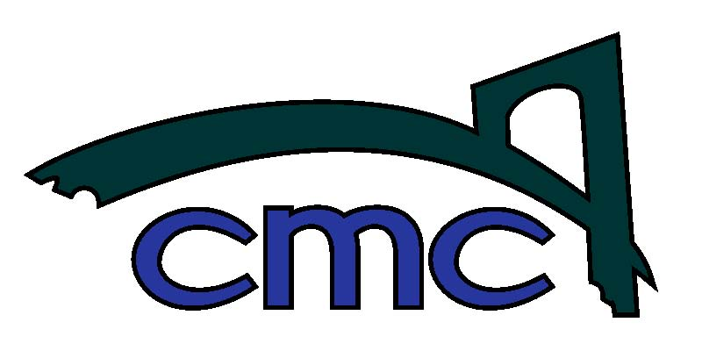

Clackamas Middle College

Phone: 503.518.5925
Fax: 503.518.5928
Clackamas Middle College
12021 SE 82nd Avenue
Happy Valley, Oregon 97086

September 1, 2016

Dear CMC Senior:
As we get underway with the 2016-2017 school year, we want to make sure that our communication is current to ensure a successful school year for you. We are scheduling two mandatory senior informational meetings so that we can update you on our program requirements and changes we have made to our Internship Experience class that is required for graduation.
In order to provide the best support and guidance, our graduating seniors will have access to CMC counselors along with CMC College and Career Center staff to help them with their Internship Experience class. Resources and support for college and career planning will be available online, in individual meetings, and throughout the year during senior workshops for students.
The times and dates for these informational nights are listed below:
Wednesday, September 7, 2016
- 5:30-6:30pm-(Seniors whose last name begins with A-M should attend this hour along with their parent/guardian for important senior requirement information)
www.clackamasmiddlecollege.org

Thursday, September 8, 2016
- 5:30-6:30pm-(Seniors whose last name begins with N-Z should attend this hour along with their parent/guardian for important senior requirement information)
*If you can’t attend during your scheduled time, please attend the other meeting
Thank you for your time and we look forward to seeing you and working with your son/daughter this school year.
Sincerely,
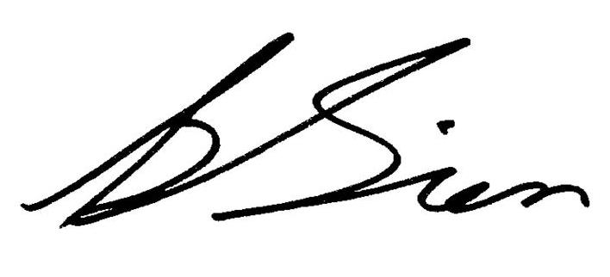
Brian Sien, Ed. D.
Principal
Clackamas Middle College

